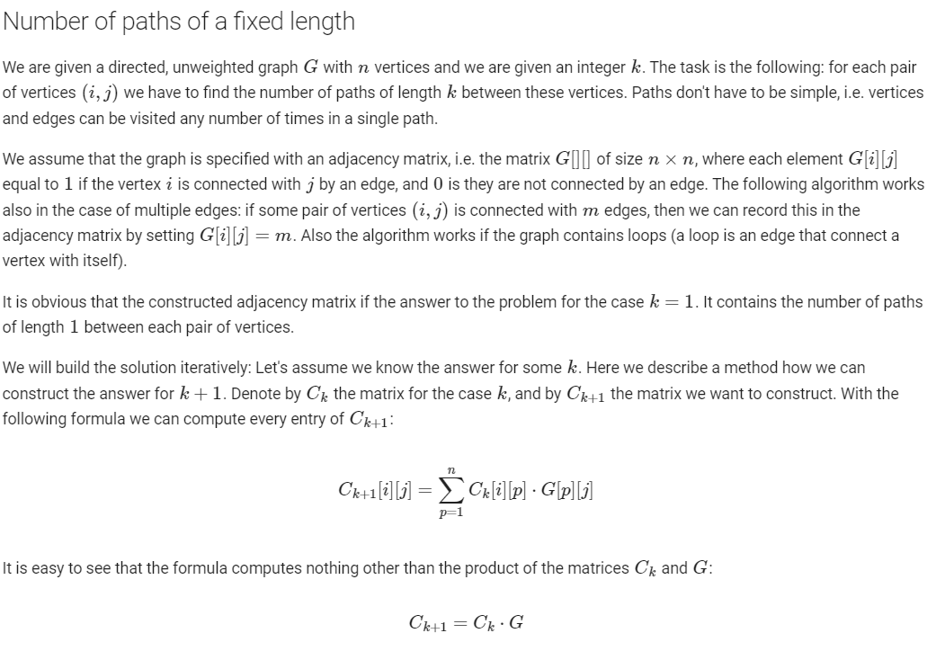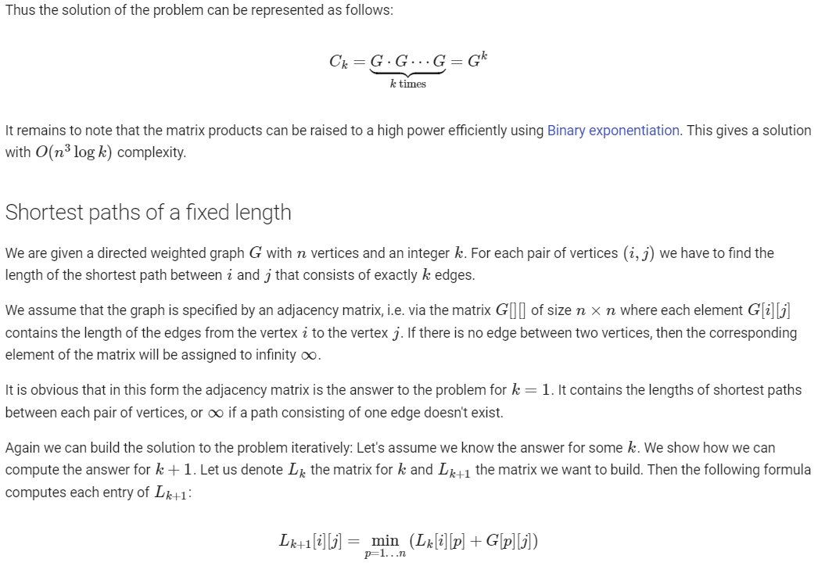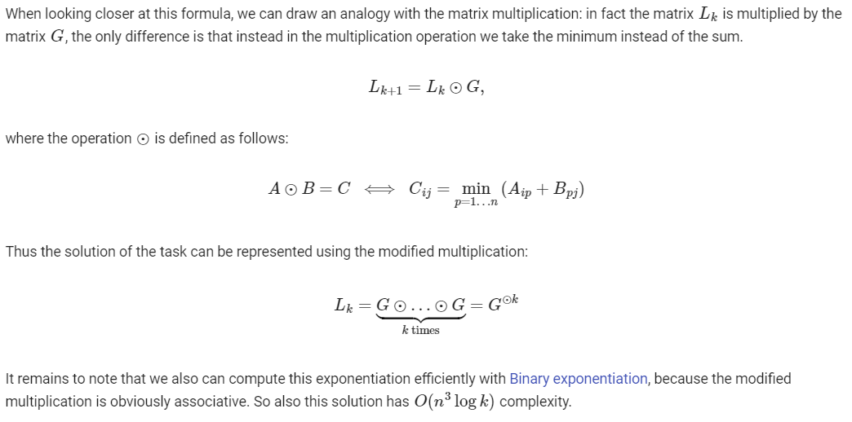



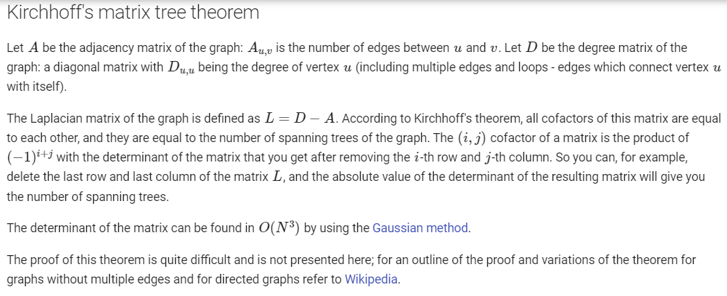

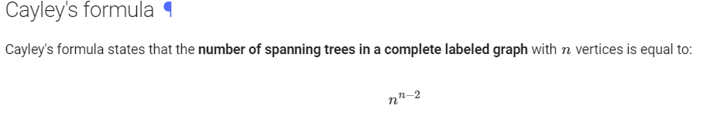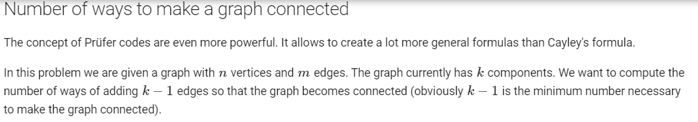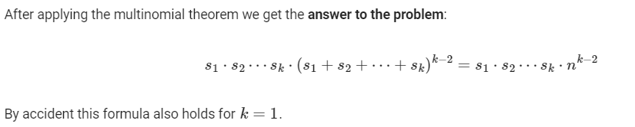


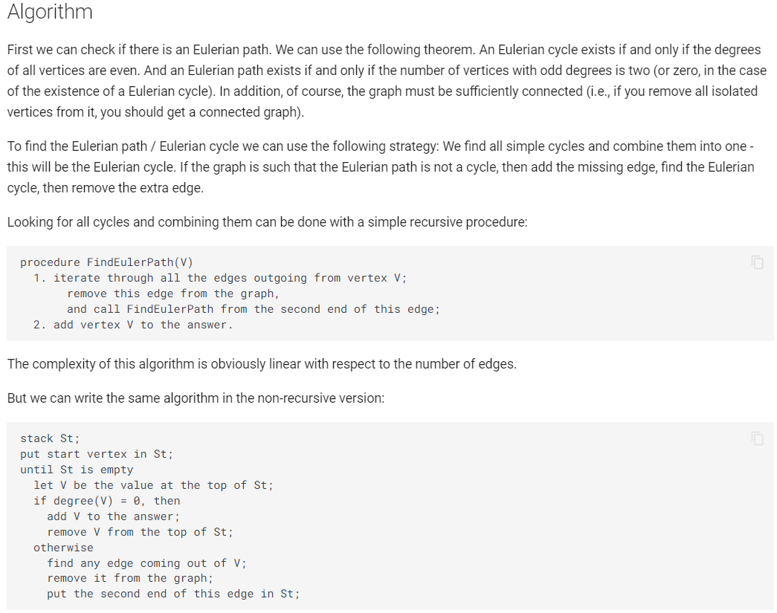

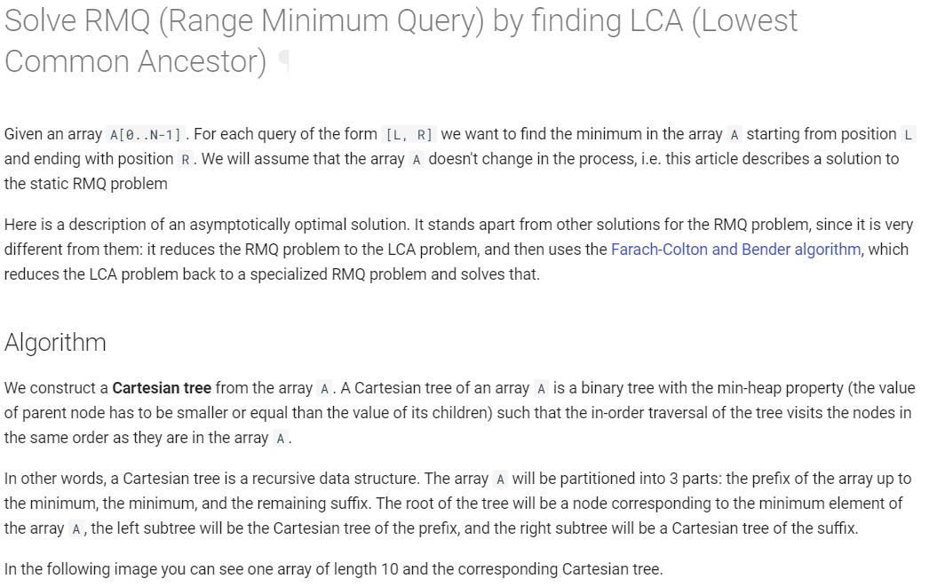
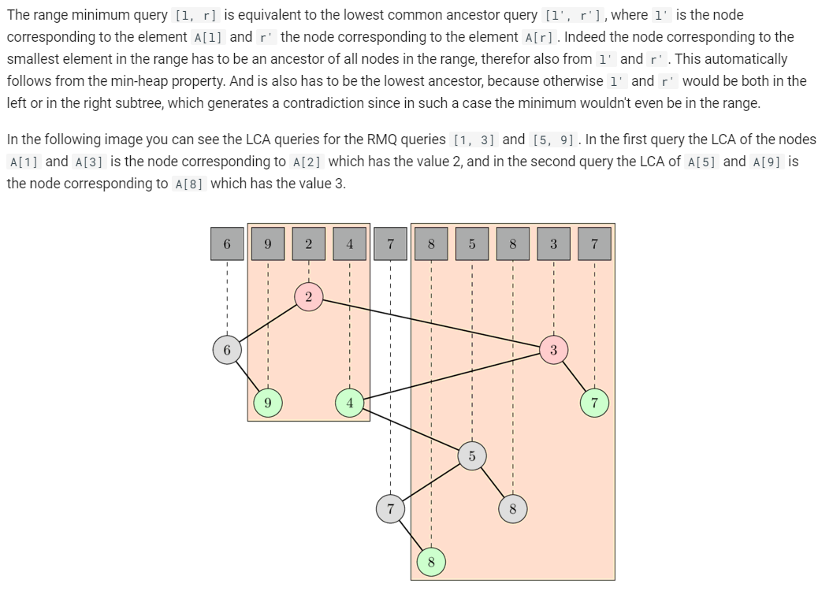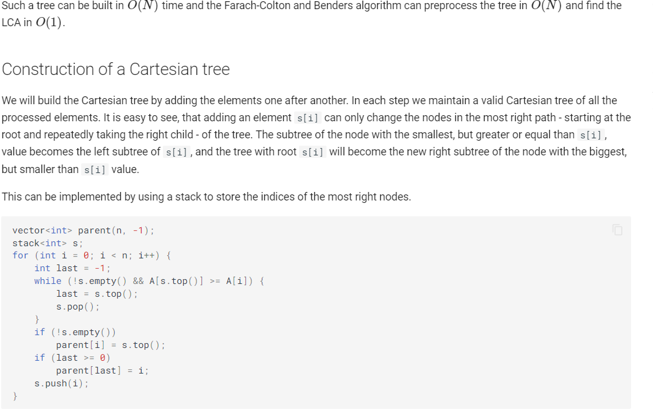


The constant INF is "infinity", i.e. some number, obviously greater than all possible numbers in the input matrix �<math xmlns="http://www.w3.org/1998/Math/MathML"><mi>A</mi></math>$A$ .
vector<int> u (n+1), v (m+1), p (m+1), way (m+1);
for (int i=1; i<=n; ++i) {
p[0] = i;
int j0 = 0;
vector<int> minv (m+1, INF);
vector<bool> used (m+1, false);
do {
used[j0] = true;
int i0 = p[j0], delta = INF, j1;
for (int j=1; j<=m; ++j)
if (!used[j]) {
int cur = A[i0][j]-u[i0]-v[j];
if (cur < minv[j])
minv[j] = cur, way[j] = j0;
if (minv[j] < delta)
delta = minv[j], j1 = j;
}
for (int j=0; j<=m; ++j)
if (used[j])
u[p[j]] += delta, v[j] -= delta;
else
minv[j] -= delta;
j0 = j1;
} while (p[j0] != 0);
do {
int j1 = way[j0];
p[j0] = p[j1];
j0 = j1;
} while (j0);
}
To restore the answer in a more familiar form, i.e. finding for each row i = 1...n the number ans[i] of the column selected in it, can be done as follows:
vector<int> ans (n+1);
for (int j=1; j<=m; ++j)
ans[p[j]] = j;
The cost of the matching can simply be taken as the potential of the zero column (taken with the opposite sign). Indeed, as you can see from the code, v[0] contains the sum of all the values of Δ, i.e. total change in potential. Although several values ​​​​of u[i] and v[j] could change at once, the total change in the potential is exactly equal to Δ , since until there is an augmenting path, the number of reachable rows is exactly one more than the number of the reachable columns (only the current row i does not have a "pair" in the form of a visited column):
int cost = -v[0];
